**DAILY ONLINE ACTIVITIES SUMMARY**

|  |  |  |  |  |  |  |  |
| --- | --- | --- | --- | --- | --- | --- | --- |
| **Date:** | **03 June 2020** | | | | **Name:** | **KHATHEEJA SAFREENA** | |
| **Sem & Sec** | **4th sem, 2nd year** | | | | **USN:** | **4AL18CS037** | |
| **Online Test Summary** | | | | | | | |
| **Subject** | | **OBJECT ORIENTED CONCEPTS (18cs45)** | | | | | |
| **Max. Marks** | | **30** | | **Score** | | **18** | |
| **Certification Course Summary** | | | | | | | |
| **Course** | **STEP INTO ROBOTIC AUTOMATION PROCESS.** | | | | | | |
| **Certificate Provider** | | | **GUVI** | **Duration** | | | **3 hours.** |
| **Coding Challenges** | | | | | | | |
| **Problem Statement :3 program** | | | | | | | |
| **Status: Executed** | | | | | | | |
| **Uploaded the report in Github** | | | | **Yes** | | | |
| **If yes Repository name** | | | | **[http://shafreenasharief / lockdown-coding](http://shafreenasharief / lockdown-coding" \o "http://shafreenasharief / lockdown-coding)**  **[http://shafreenasharief / locked-down--certification-course](http://shafreenasharief / locked-down--certification-course" \o "http://shafreenasharief / locked-down--certification-course)**  **[http://shafreenasharief / Daily\_Report](http://shafreenasharief / Daily_Report" \o "http://shafreenasharief / Daily_Report)** | | | |
| **Uploaded the report in slack** | | | | **Yes** | | | |

Online Test Details: (Attach the snapshot and briefly write the report for the same)

Certification Course Details: (Attach the snapshot and briefly write the report for the same)

Coding Challenges Details: (Attach the snapshot and briefly write the report for the same)

**ONLINE TEST SUMMARY**:

Today **OBJECT-ORIENTED CONCEPTS (18cs45)** was conducted of first module. Total marks for the test was 30.

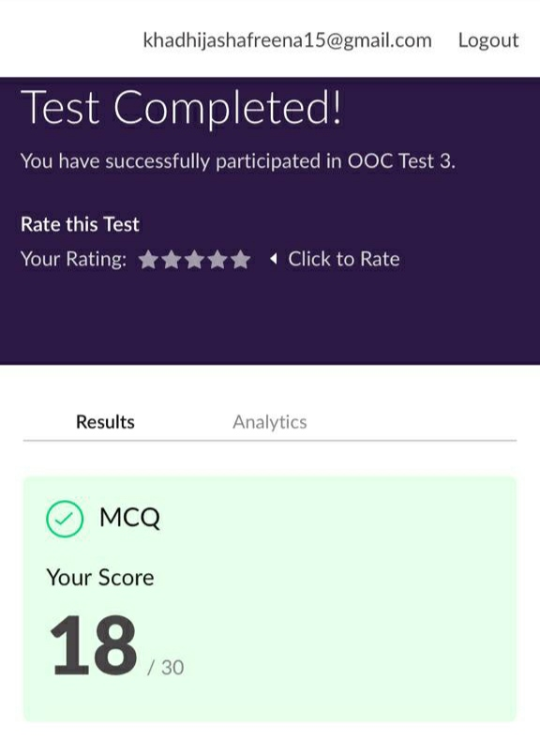

**CERTIFICATION COURSE SUMMARY:**

Today I started new certificate course on**ROBOTICS PROCESS AUTOMATION** by **GUVI**  .It was three hours course. I successfully completed the course and secured a certificate .By the end of the session I attempted quiz ,which gave me a clear veiw about the topics that were thought and discussed.

**The concept covered in the course are as follows:**

* Describe robotic process automation
* Describe the impact of RPA on the future work
* List the benefits of RPA.
* Understand a robot & it's types.

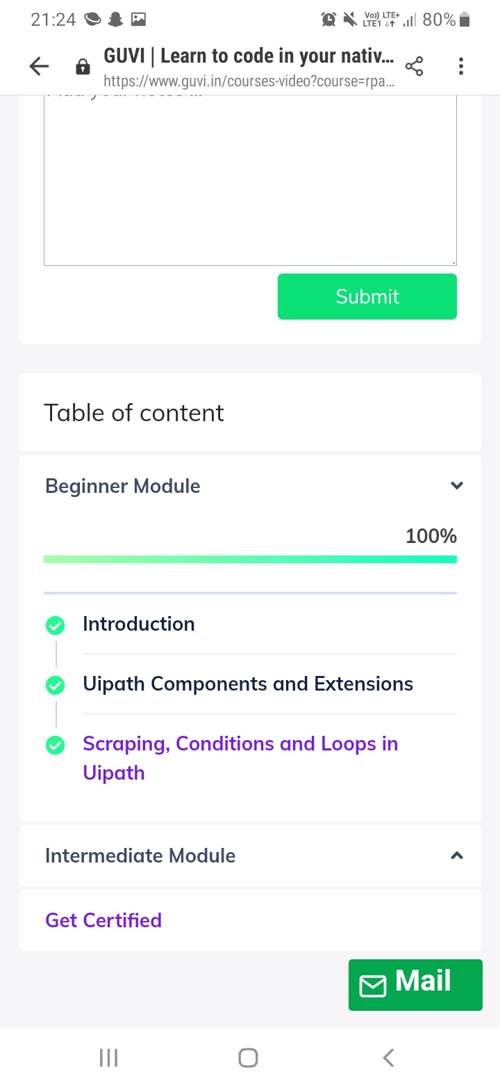



* **There is the snapshot of the certificate on competition of course.**



**DAILY CODING CHALLENGE:**

Today I solved 3 coding challenge,

**Problem Statement 1:**

**Write a code segment in java to swap two numbers using call by object reference**.

**Problem Statement 2:**

**Write a Java program to find Last Digit of a^b (a to the power b) for Large Numbers**

You are given two integer numbers, the base a (number of digits d, such that 1 <= d <= 1000) and the index b (0 <= b <= 922\*10^15). You have to find the last digit of a^b.

Examples:

Input: 3 10

Output: 9

Input: 6 2

Output: 6

Algorithm:

Since number are very large, we store them as a string.

Take last digit in base a.

Now calculate b%4. Here b is very large.

-> If b%4==0 that means b is completely divisible by 4, so our exponent now will be exp = 4

because by multiplying number 4 times, we get the last digit according to cycle table in

above diagram.

->If b%4!=0 that means b is not completely divisible by 4, so our exponent now will be

exp=b%4 because by multiplying number exponent times, we get the last digit according to

cycle table in above diagram.

-> Now calculate digit = pow( last\_digit\_in\_base, exp ).

->Last digit of a^b will be ldigit%10.

**Problem Statement 3:**

**Write a function that takes a two-digit number and determines if it's the largest of two possible digit swaps.**

To illustrate: largestSwap(27) ➞ false largestSwap(43) ➞ true If 27 is our input, we should return false because swapping the digits gives us 72, and 72 > 27. On the other hand, swapping 43 gives us 34, and 43 > 34. Examples largestSwap(14) ➞ false largestSwap(53) ➞ true largestSwap(99) ➞ true

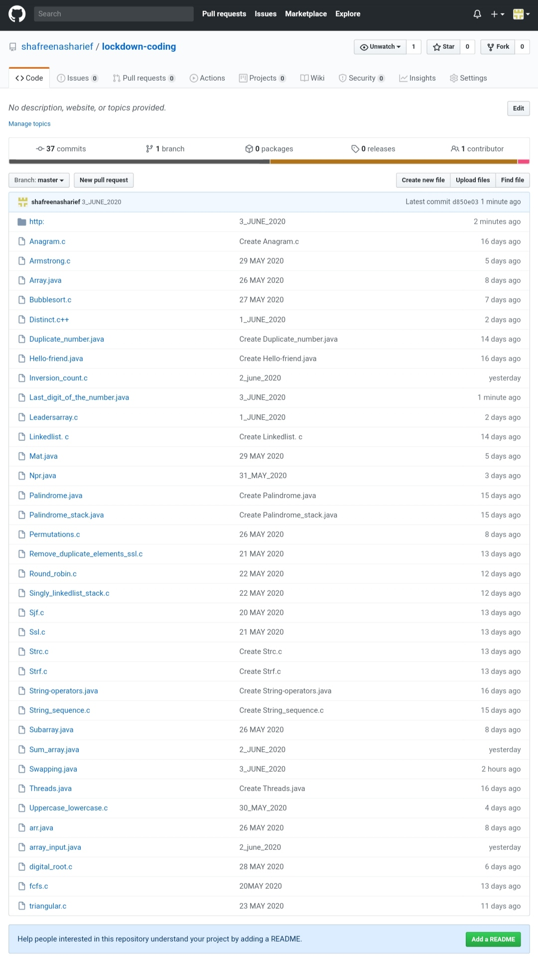

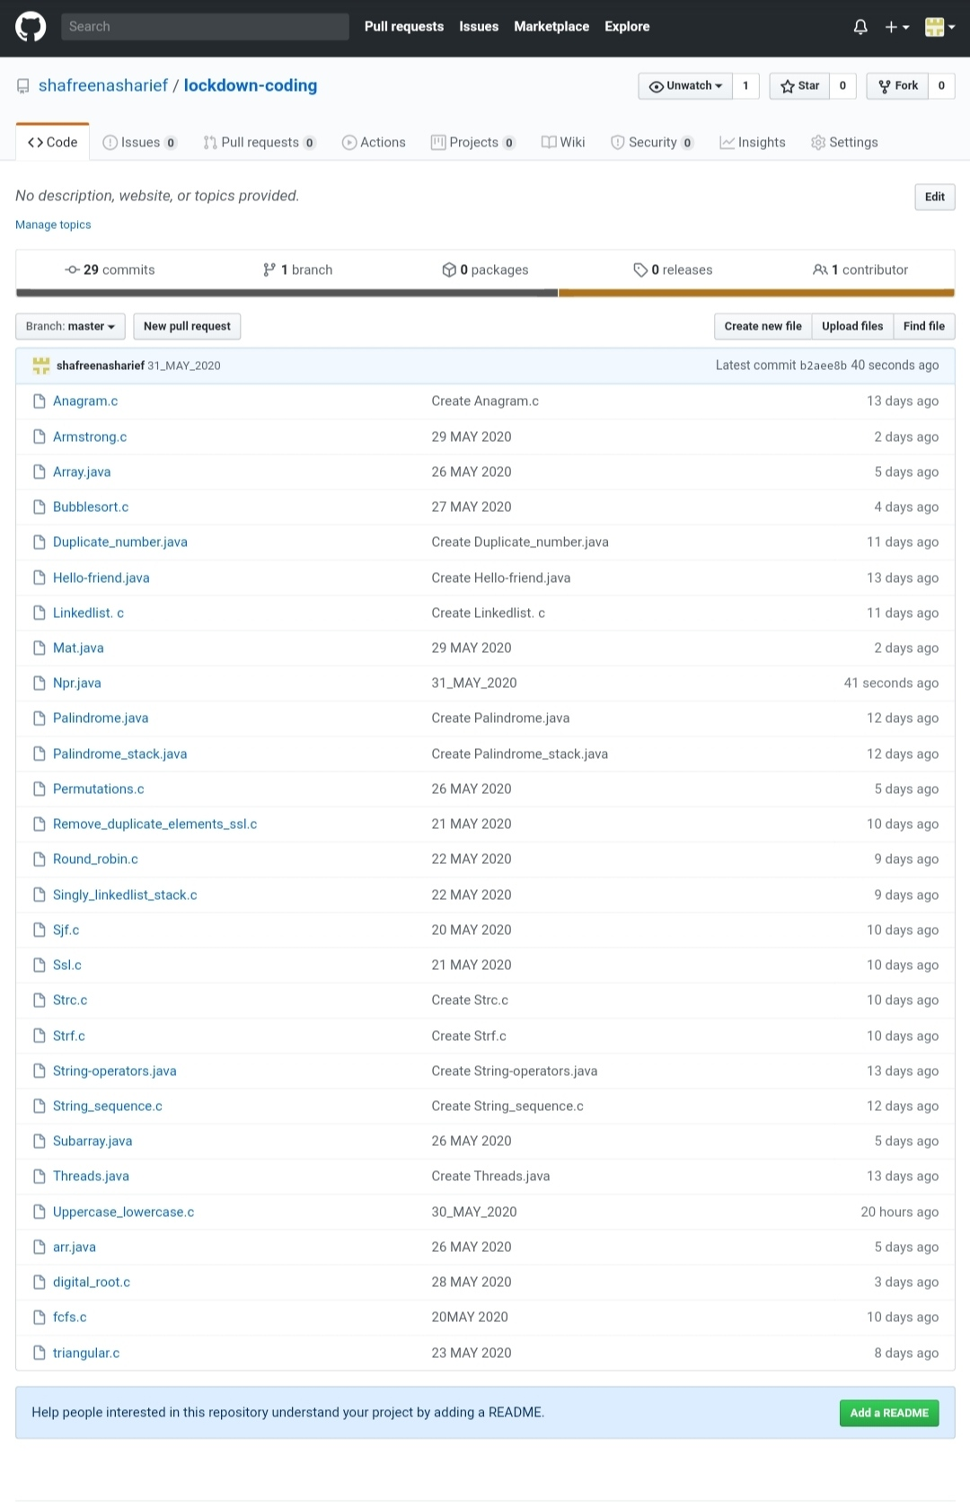**SOLUTION** : I have uploaded the solution of the above 4 coding problems in my GitHub repository.

http://shafreenasharief / lockdown-coding

[http://shafreenasharief / locked-down--certification-course](http://shafreenasharief / locked-down--certification-course" \o "http://shafreenasharief / locked-down--certification-course)

[http://shafreenasharief / Daily\_Report](http://shafreenasharief / Daily_Report" \o "http://shafreenasharief / Daily_Report)